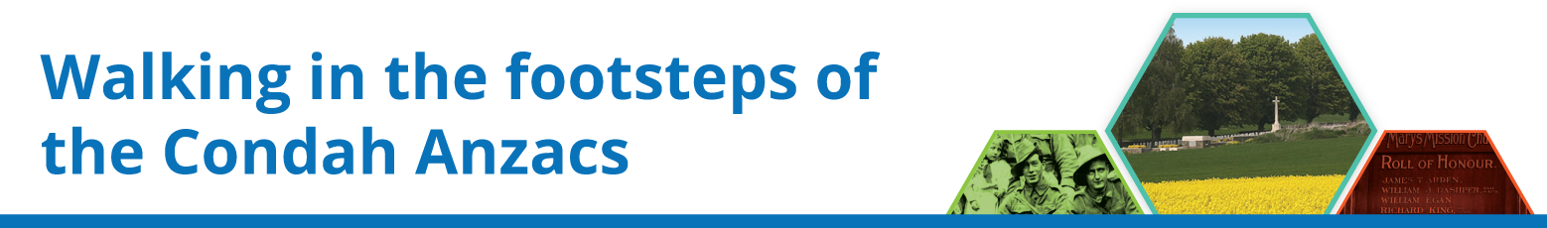

Activity 1 – Video Comprehension Questions
1 Describe today’s Condah.

2 How was Condah special to Aboriginal people in the time before European settlement?

3 What happened to Aboriginal life after European settlement?

4 What was Condah like in 1914?

5 How did the community respond to the outbreak of war? Why did it respond in this way?

6 The film switches to Villers-Bretonneux. What happened there in April 1918?

7 Why would Australian students visit this place?

8 Why are local children urged to ‘Always Remember Australia’?

9 What other connections between Condah and France/Belgium did the presenter find on the Western Front?

10 The presenter finds two names from Condah at the Australian National Memorial. How are they more than just names? What does their existence in both places tell us about connections between Condah and the French and Belgian communities?

11 The events of the war were 100 years ago. Is it important to know about and understand what happened to individuals and communities then? Explain your reasons.
12 The links that the presenter explores between men from one community and communities overseas were also 100 years ago. Are those links still important to young people today? Are they worth maintaining? Explain your view. If so, how can we do this?

